Lesson Plan for Introduction to Special Relativity
-As taught by Ryan Normandin-

Approximate Outline:
- Introduction, Relativity of Simultaneity, Discussion of Time (15 minutes)
- Time Dilation (10 minutes)
- Length Contraction (10 minutes)
- Black Holes, Discussion (5 minutes)
- E = mc² (10 minutes)
Note: A good part of the appeal of special relativity is that it’s strange and counterintuitive. Therefore, the goal of this class is not to rigorously develop the Lorentz transforms or run calculations with space-time diagrams, but to present what I remember thinking were the coolest results of the theory. As such, I don’t particularly care whether I get through everything I wanted to cover; to be honest, more often than not, I’ve excluded the E = mc² derivation because of the excellent discussion that arises. If you indulge this discussion, you should have background in physics such as E&M, Special Relativity, basic idea of the concepts of GR, some knowledge of Einstein’s life, and quantum mechanics. However, the class can also be run without this knowledge, but that means that the teacher should stick to the lesson plan and not indulge as much discussion. Additionally, a wonderful aspect of the subject presented at this level is that the mathematics required are algebra and the Pythagorean Theorem, which means small mathematical input for large physical output.

Introduction, Relativity of Simultaneity, Discussion of Time
Begin with a discussion of the relativity of simultaneity, setting up a thought experiment where a double-sided flashlight shoots a photon toward the front and back of a train, while that train travels to the right with a velocity of v.
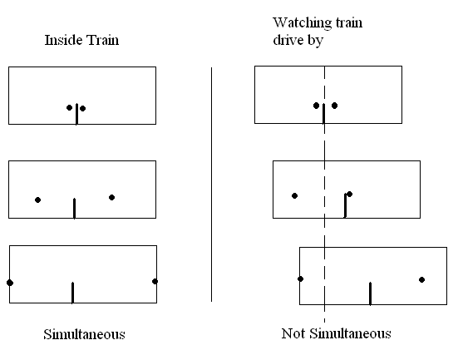
Thus, no such thing as absolutely simultaneity.
Discussion on time: A good way to define the present moment in time is the set of all simultaneous events happening at the moment you are considering. However, no absolute simultaneity means no absolute present, people move through time at different rates, special relativity shows that the past and future(s) all exist at the same “time.”
Let’s quantify the differences in time we observed with the train!
Time Dilation
Again, we have a train traveling to the right at a velocity of v. This time we put a mirror on the bottom of the train and a mirror on the ceiling directly above it and bounce a photon from the bottom to the top, then back to the bottom. We examine this thought experiment in two scenarios: an observer inside the train and outside the train, watching it drive past.
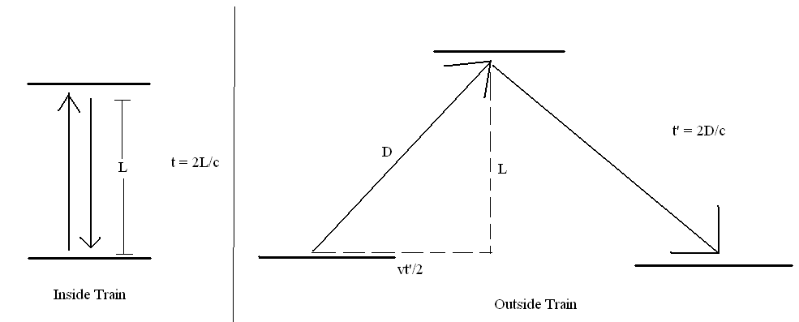

Do derivation of time dilation, be sure to explain what you’re doing and why you’re doing it.
D² = L² + (vt’/2)²
D = sqrt(L² + (vt’/2)²)
t’ = 2D/c = 2 x sqrt(L² + (vt’/2)²)/c
(ct’/2)² – (vt’/2)² = L²
t’ = 2L/(sqrt(v² – c²))
t’ = 2L/c(sqrt(1 – v²/c²))
2L/c = t
t’ = t/sqrt(1 – v²/c²) Time Dilation
I usually do more of the algebra out, this is just to show you what you should be doing and I don’t enjoy Microsoft Word’s equation editor.
Why don’t we see time dilation in our everyday lives? Plug in speed of light, v = 30 m/s down the highway, t’ is just about equal to t.
During this derivation, we noticed that the lengths traveled in the two scenarios are different! Let’s quantify that!

Length Contraction
Again, same train setup, but with mirrors on front and back instead of top and bottom.
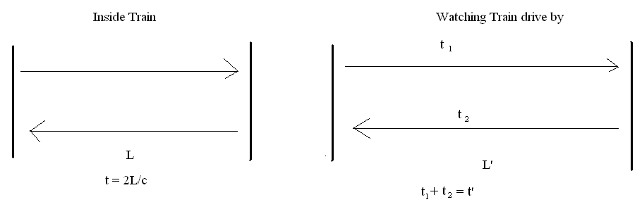
L’ + vt₁ = ct₁
L’ – vt₂ = ct₂
t₁ = L’ / (c – v)
t₂ = L’ / (c + v)
t₁ + t₂ = t’ = 2L’c / (c² – v²) = 2L’ / c (1 – v² / c²)
Use time dilation: t’ = t/sqrt(1 – v²/c²) = 2L/ c (sqrt(1 – v² / c²))
2L/c (sqrt(1 – v²/c²)) = 2L’/ c ((1 – v² / c²)
L’ = L (sqrt(1 - v² / c²) Length Contraction

Depending on time, I occasionally will talk about black holes, since time dilation occurs and you can look at it from different frames of reference (person jumping in is destroyed instantly, person watching observes time dilation and sees the person stop moving as time stretches to infinity, you can compare this to plugging in c for v in the time dilation equation, but be sure to mention that the time dilation is due to gravity, not movement). Person watching sees person who jumped in slowly fade away as light bouncing off them is redshifted and fewer and fewer photons bounce off.

Time allows, E = mc² (the following is copy-pasted from http://www.adamauton.com/warp/emc2.html)
First, imagine a stationary box floating in deep space. Inside the box, a photon is emitted and travels from the left towards the right. Since the momentum of the system must be conserved, the box must recoils to the left as the photon is emitted. At some later time, the photon collides with the other side of the box, transferring all of its momentum to the box. The total momentum of the system is conserved, so the impact causes the box to stop moving.
Unfortunately, there is a problem. Since no external forces are acting on this system, the centre of mass must stay in the same location. However, the box has moved. How can the movement of the box be reconciled with the centre of mass of the system remaining fixed?
Einstein resolved this apparent contradiction by proposing that there must be a ‘mass equivalent’ to the energy of the photon. In other words, the energy of the photon must be equivalent to a mass moving from left to right in the box. Furthermore, the mass must be large enough so that the system centre of mass remains stationary.
Let us try and think about this experiment mathematically. For the momentum of our photon, we will use Maxwell’s expression for the momentum of an electromagnetic wave having a given energy. If the energy of the photon is E and the speed of light is c, then the momentum of the photon is given by:
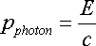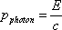
(1.1)
The box, of mass M, will recoil slowly in the opposite direction to the photon with speed v. The momentum of the box is:
(1.2)
The photon will take a short time, Δt, to reach the other side of the box. In this time, the box will have moved a small distance, Δx. The speed of the box is therefore given by
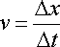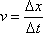
(1.3)
By the conservation of momentum, we have
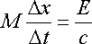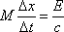
(1.4)
If the box is of length L, then the time it takes for the photon to reach the other side of the box is given by:
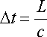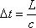
(1.5)
Substituting into the conservation of momentum equation (1.4) and rearranging:
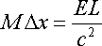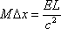
(1.6)
Now suppose for the time being that the photon has some mass, which we denote by m. In this case the centre of mass of the whole system can be calculated. If the box has position x₁ and the photon has position x₂, then the centre of mass for the whole system is:
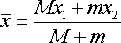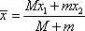
(1.7)
We require that the centre of mass of the whole system does not change. Therefore, the centre of mass at the start of the experiment must be the same as the end of the experiment. Mathematically:
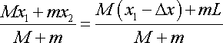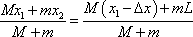
(1.8)

The photon starts at the left of the box, i.e. x₂ = 0. So, by rearranging and simplifying the above equation, we get:

(1.9)
Substituting (1.4) into (1.9) gives:
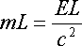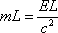
(1.10)
Rearranging gives the final equation:
So, let’s think about what this equation means. The equation suggests that a given mass can be converted into energy. But how much energy? Well, suppose we have a kilo of mass. Conversion of this mass into pure energy would result in (1kg * c²) joules of energy. Now note that c² = 8.99 * 10¹⁶ m²s⁻² so that's a WHOLE lot of energy - equivalent to 21.48 megatons of TNT!
In practice, it is not possible to convert all of the mass into energy. However, this equation led directly to the development of nuclear energy and the nuclear bomb - probably the most tangible results of special relativity.

