Advents
An Introduction to English Poets and Poetry
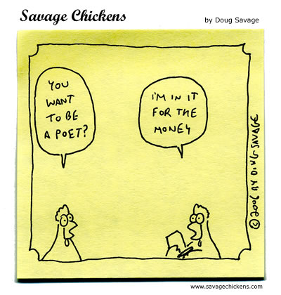
Instructor
Samantha Berstler
sberstler@college.harvard.edu
Candidate for A.B. in English,
Harvard University

A poem conveys not a message so much as the provenance of a message, an advent of sense.
Thomas Harrison

Format
Each class will be divided into a “critical” and “creative” half. During the critical portion of the class, we will read and analyze a wide variety
of poetry from diverse historical moments and theoretical schools. During the creative part of the class, we will focus on building poetic technique and crafting strong poems through workshop-style critique.

Week 1:
What is poetry? What is genre? What is a prose poem?
Workshop: free-writing, word-generating exercises, finding “energy” in
word juxtaposition

Week 2:
Anglo-Saxon England (West Saxon Poetry)
“The Wanderer”; “The Seafarer”
Workshop: using alliteration, anaphora; stretching the metaphor

Week 3:
The Renaissance
“Sonnet 18” (Shakespeare); “The Flea” (Donne); “The Passionate Shepherd to His Love” (Marlowe)
Workshop: the line and the stanza; form; the limits of rhythm and meter

Week 4:
Romanticism
“Ode to a Grecian Urn” (Keats); “To a Skylark” (Shelley); “She Walks in Beauty” (Byron)
Workshop: Romanticism in contemporary poetry (and its dangers)
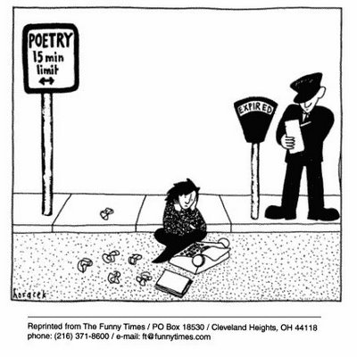
Week 5:
The First World War
“Everyone Sang” (Sassoon); “Greater Love” (Owen); “Dulce et Decorum Est” (Owen)
Workshop: narrative poetry; witness poetry

Week 6:
Modernism
“The Love Song of Alfred J. Prufrock” (Eliot)
Workshop: how to revise

Week 7:
Contemporary Poetry
Bring in one poem from a major literary magazine (many major literary magazines are online)
Workshop: open prompt

Week 8:
Bring in one poem by a famous poet and one of your own poems

